PDPA Thailand Compliance for Log360
Strengthen data protection and meet PDPA Thailand compliance with Log360.
Region: EU, Thailand | Type: Data Privacy | Category: Compliance | Pricing: Free

Overview
The PDPA Thailand compliance extension in Log360 helps organizations meet Thailand's Personal Data Protection Act by providing centralized log management, consent-aware access auditing, real-time breach detection, and compliance event reporting. The platform supports PDPA Thailand requirements for lawful basis and consent management, data subject rights fulfillment, minimum technical security measures, breach notification within 72 hours, Records of Processing Activities maintenance, Data Protection Officer oversight, and cross-border transfer compliance.
For Lawful Basis and Consent Management, Log360 tracks authentication events, policy changes, and user activity to monitor compliance with consent-based access controls and detect processing outside declared lawful grounds. To address Data Subject Rights — Access, Rectification, Erasure and Portability, the platform monitors user account management, Entra ID changes, and database account modifications to trace authorization workflows for data subject rights fulfillment. The extension also supports Security Measures — Technical and Organizational Controls by providing capabilities that monitors failed authentications, MFA enforcement, file integrity, Windows threat detection, and firewall events to maintain a technical security posture meeting PDPA minimum security requirements.

Key Features
- Breach Detection and Notification to the PDPC: Log360 enables timely breach detection through threat monitoring, anti-malware alerts, network attack reports, and exchange security events to meet the 72-hour notification window.
- Record of Processing Activities (ROPA) Maintenance: Log360 provides event log reports, process tracking, system event auditing, and database audit trails to create a comprehensive audit trail supporting ROPA documentation requirements.
- Data Protection Officer Activities and Oversight: Log360 tracks role assignments, Entra ID user management, GPO modifications, and OU management to support DPO oversight of data protection controls across the organization.
- Cross-Border Data Transfers and Processor Obligations: Log360 monitors AWS infrastructure, cloud IAM permissions, Salesforce activity, and cross-cloud authentication to verify that data transferred outside Thailand maintains PDPA-required protection levels.
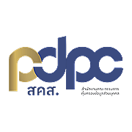

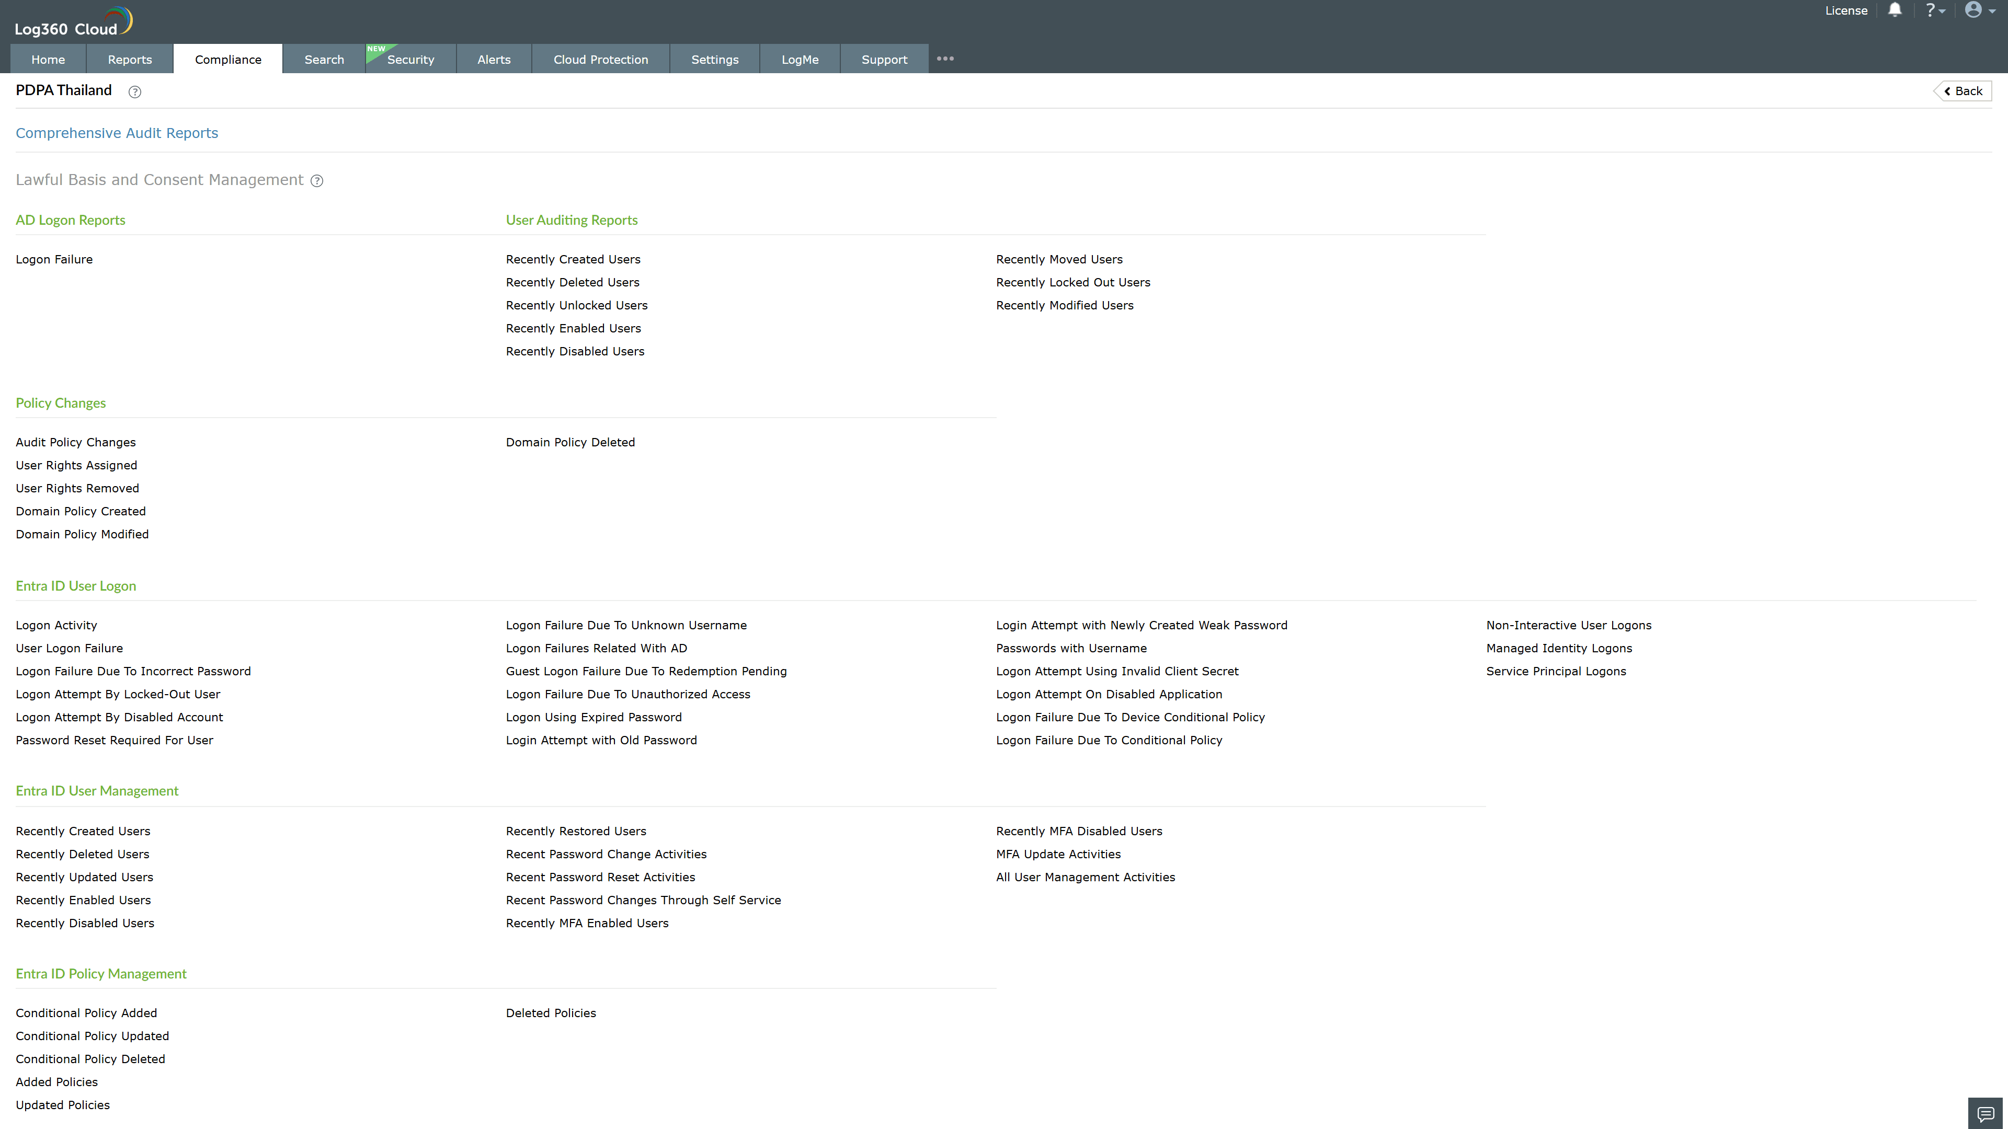
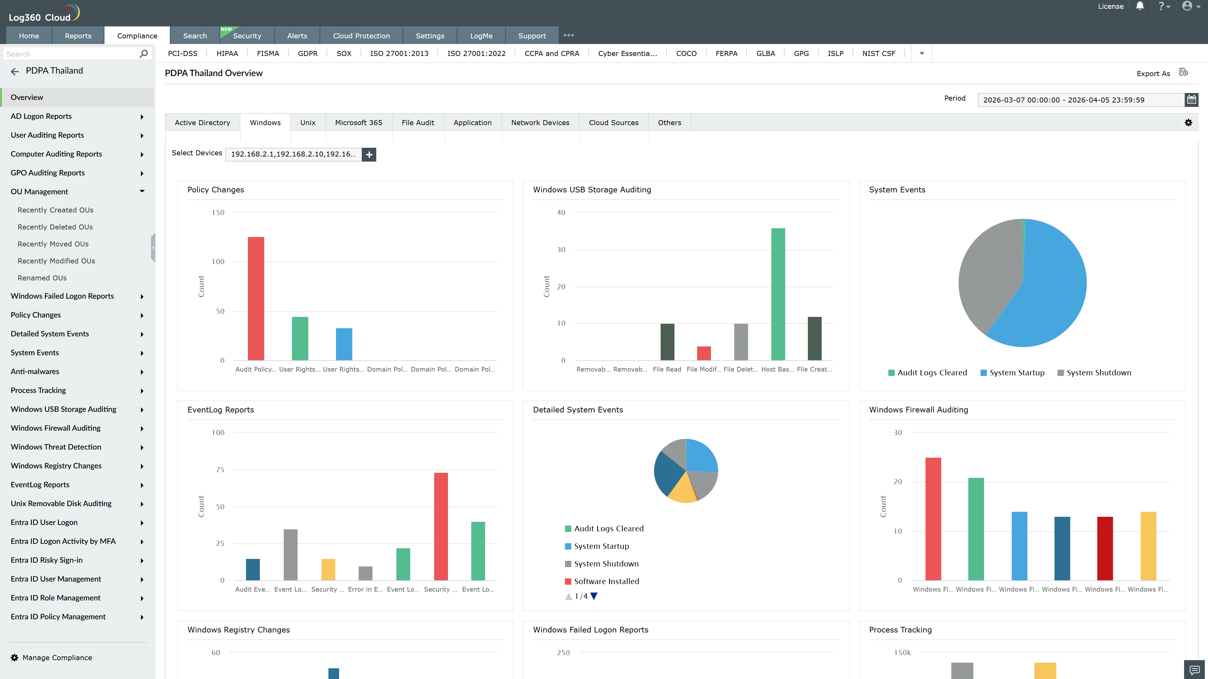
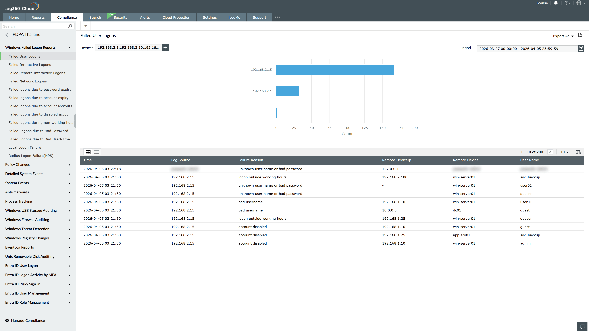
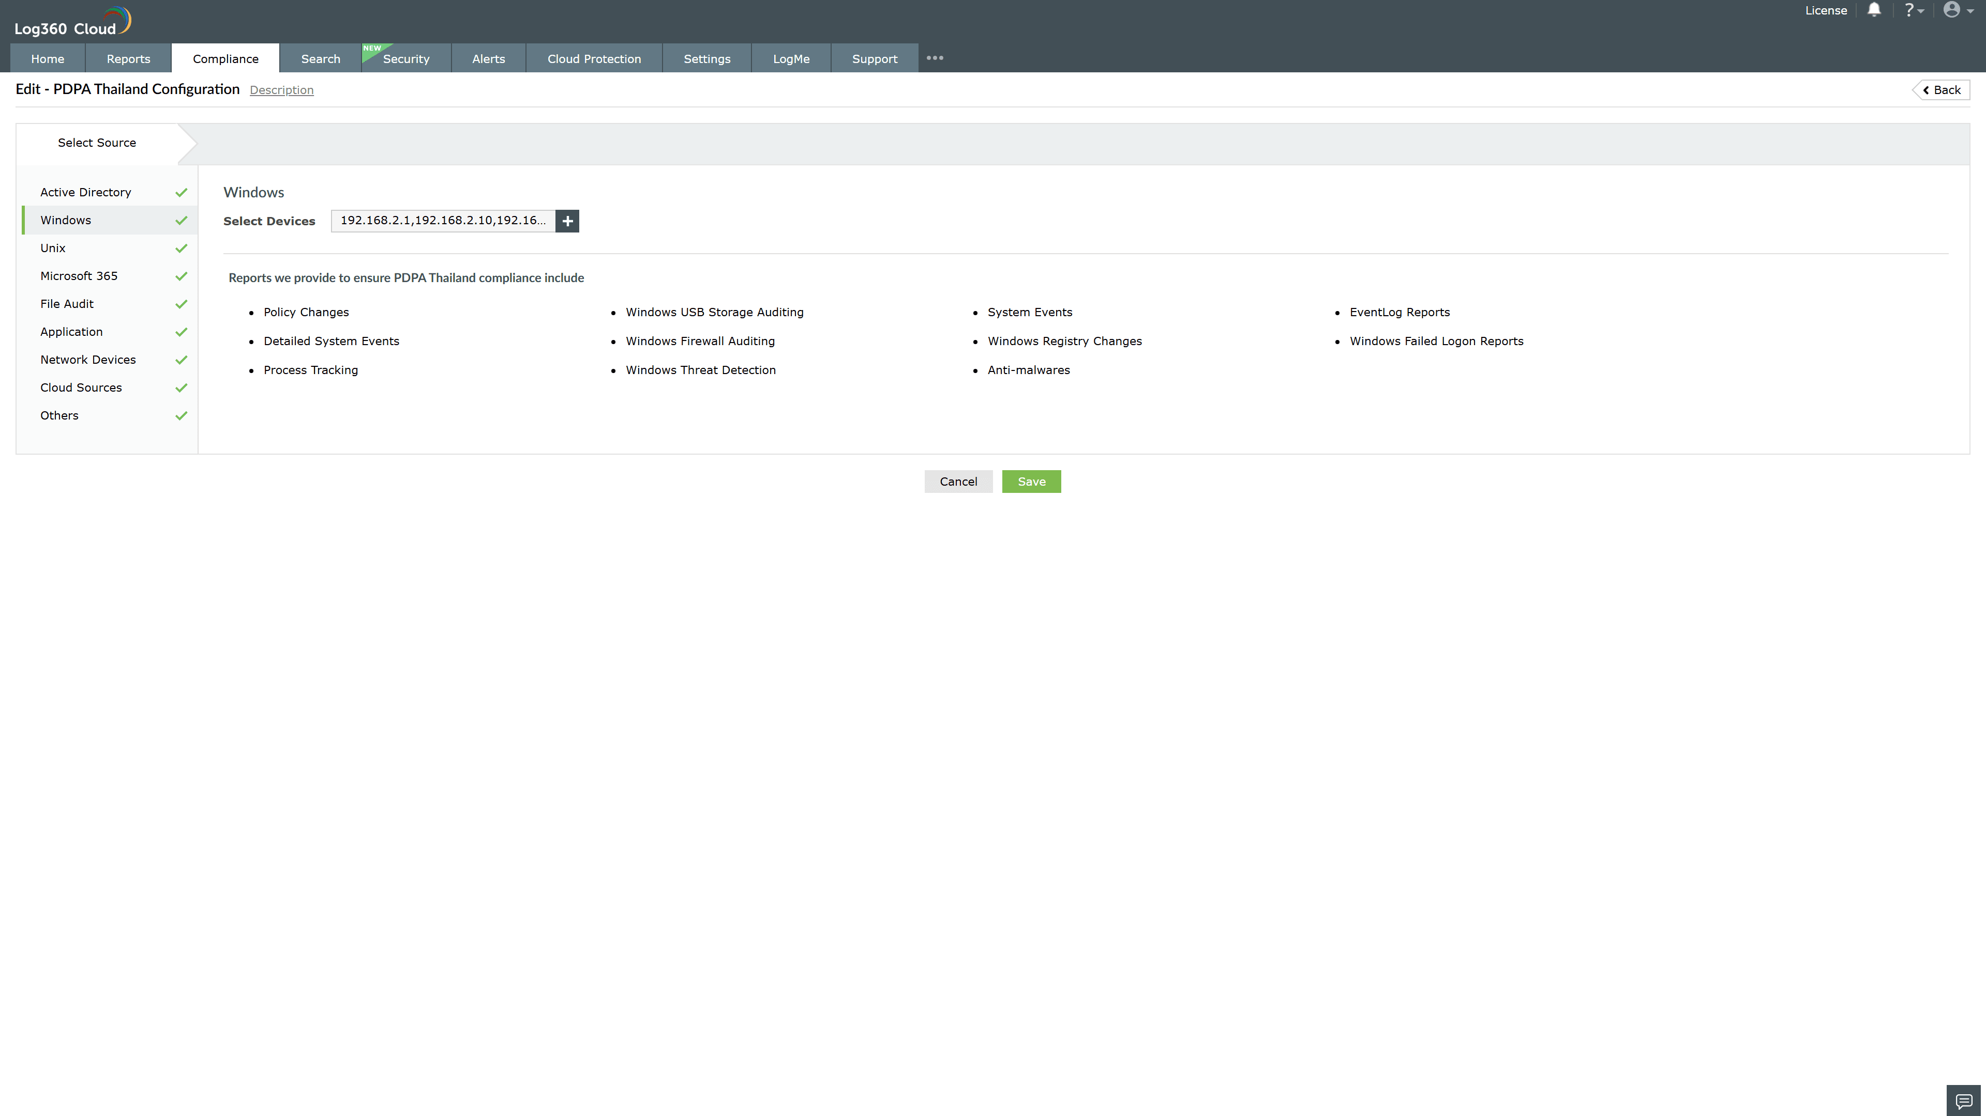
Valid Submission : Yes
Supported Editions : Free, Basic, Standard, Professional, MSSP
Help Document : https://www.manageengine.com/log-management/help/integrations/compliance-extensions.html
Help Video : Not provided
Tags : Log360, Compliance, Privacy monitoring, Data privacy, Regulatory compliance
Supported DCs : US, IN, JP, CA, AU, UK and EU
Privacy Policy:
Terms of Service:
Release Notes:
Predefined reports for the PDPA Thailand.

